VR technology Lab I Report

Name: Dazhi Li

RUID: 197007456

YouTube link : <https://youtu.be/IjKCg59auP4>

1. Abstract

What I have achieved in my first homework is a spooky scene with background music. This is all shown in figure 1. The abandoned city is surrounded by dark jungles which is giving the feeling of being alone and undirected to the player. However, the most critical thing which will make the whole thing terrifying in my work is adjusting the light intensity and environment exposure. Vison is a good feedback channel for human to feel terrified. Dark environment makes most of human feel uncomfortable with some scary abandoned buildings and a graveyard.

Figure 1

1. Overview of Procedure

The first thing I need to do is building a scene. As we know we stand on the earth because of the ground. The first stuff in my scene must be a solid ground **[figure 2]** which will hold our player in my scene. The size of the playground depends on how large I wish my scene would be and how much time and energy I have. Then some ideas come to my mind and tell me how can I do. The inspiration of how a spooky scene would be is very important. From figure 2, I divide my scene for 4 parts.

Figure 2

No.1 part is an abandoned building area, No.2 is the graveyard area, No.3 is the resident area and No.4 is the office area. All of them look so old as I tried the normal map in figure 2 to make them overwhelmed. According to the lab 1 attached file I built a road to dived the scene, which is accomplished by a plane on the ground with road textures. Part 1 and 2 are mainly prefabs from the unity free asset store. Part 3 and 4 are mainly achieved by textures downloaded from the web and cube model. After I made up the brief view of my scene, what I am going to do next is adding some terrifying decoration item to make it spooky. These things include dark lamp, dirty cone, abandoned trunks and etc. These decoration will be shown in **figure 3**.

The final step of making a spooky scene is adjusting the lights which is very essential in this lab. Skybox will build the further scene in my project. I use some trees to fit into my cloudy forest skybox and change the light intensity to make it darker **[Figure 4]**. Moreover, I rotate the skybox to fit my scene, that is to say, I posed the skybox to make the forest in its correct position which will make this whole scene reasonable. Then it comes to the light problem. I shut off the direct light and make the light intensity of skybox lower to make this whole scene seems like in the evening. In my opinion, normal daylight city would not have a point to frighten any people in most situations. Then a problem comes out that it is not able for us to see the street view and buildings. Dark lamp is the key to solve this problem and even makes the scene spookier. I use the point light on the lamp to make it more like the real light in our world. The status of all the light will be included in **figure 5**. However, lamp is built on the road but not the sky. I also have to choose some lights in the sky which will make it clearer to see the top of high buildings. Normal direct will light the whole city up which is not what I am expecting as it will make the scene not scary. As a result, I choose the spot light to light up some parts of the city which will actually accomplish our goal.

Figure 3

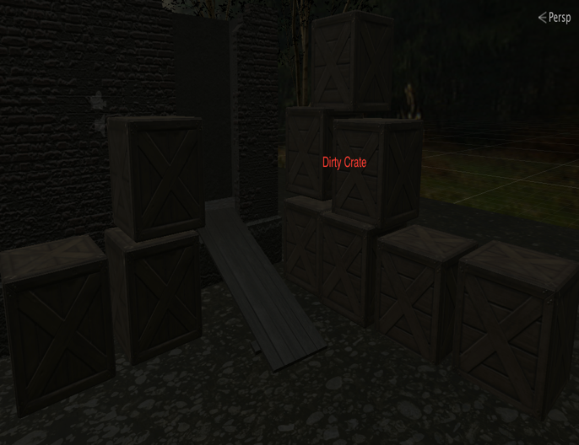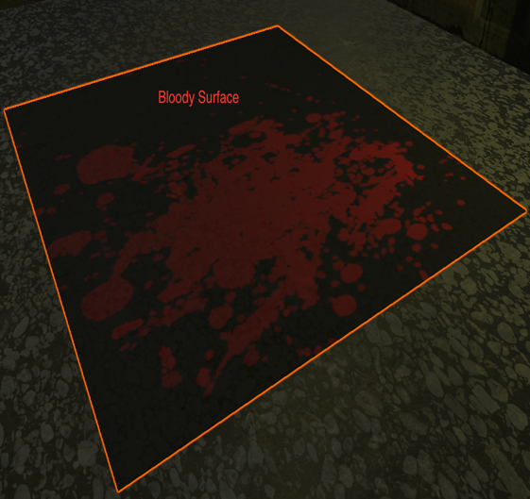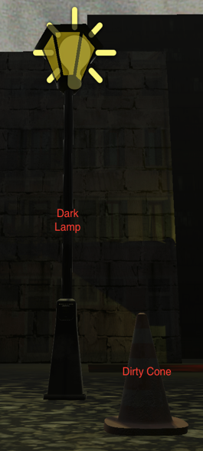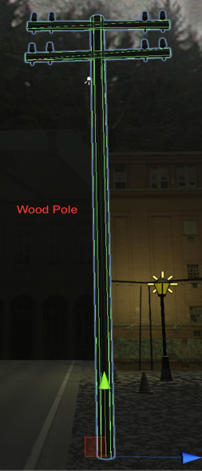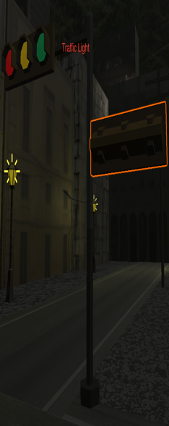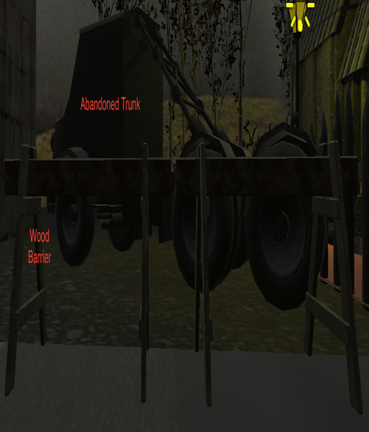

After everything positioned, I add a scary sound and FPS controller to finish my lab.

Figure 4

Figrue 5

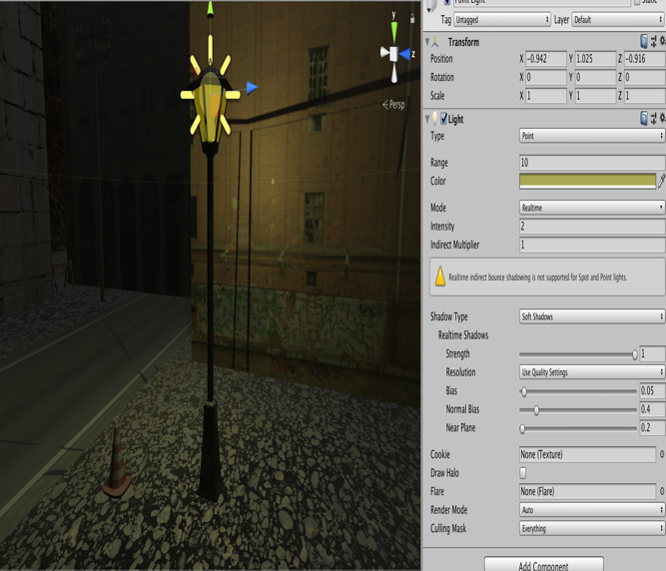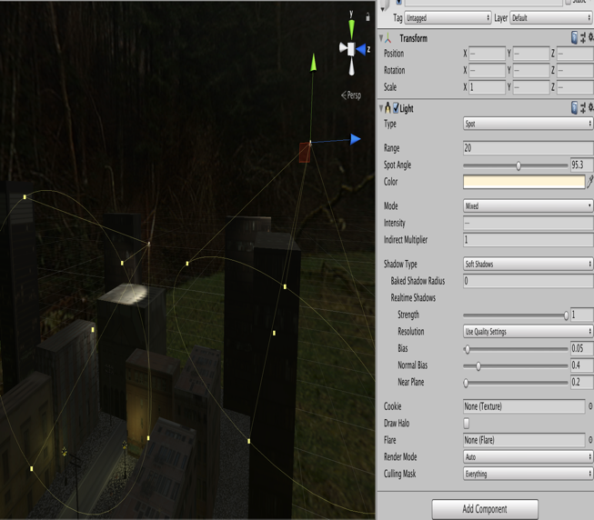

1. Conclusion and Future work

The way to make a spooky scene could be concluded into 3 points. Firstly, choosing the right models and textures. This will make our city view like an empty one. The real fear comes from a human is being alone without anybody in an empty space. Secondly, making the decoration fitting to the environment. Only reasonable could be accepted by human’s minds. Thirdly, light intensity will influence strongest. We can use light to show what we want our guest to see and what we do not wish our guest to see.

After this lab, I think there are still many things I can do to make my scene better. I will choose better textures in my buildings to make them more real. Adding rigidbody component to decorations will make the virtual world more realistic. Finally, adding some monsters or zombies would also make it scary.